**SNOW CRAB FECUNDITY PROTOCOL (EGG COUNTING)**

Reproductive output of the female component snow crab in a population varies with the abundance of females as well as their individual fecundity (i.e. the number of eggs per female). Fecundity is known to depend on size, maturity stage (first or second clutch), age and health of females. In turn, these factors vary from year to year and in different regions. However, estimating egg counts from sampled females is a time-consuming process, involving drying, cleaning, egg counting and weighing of biological samples. We seek here to develop methods for estimating individual female fecundity which require fewer laboratory steps, all while characterizing the precision or bias associated with each proposed method. Such methods may then be applied in future monitoring of variations in individual female fecundity in the southern Gulf of St Lawrence snow crab population. Such variations have been highlighted in neighbouring populations in Québec and Newfoundland.

**Laboratory security: The eggs are preserved in formalin. Avoid skin contact and exposure to fumes: use lab coat, latex gloves, glasses, mask and work under the fume hood prior to drying.**

1. **Equipment**

* Fume hood
* Drying oven
* Dissection microscope
* Formalin solution 10% (Fisher Scientific)
* Chemical waste container
* Scissors
* Vernier caliper
* Tweezers and probe
* Vials containing Bouin’s solution (4%)
* Small mesh fish net
* Funnel
* Wash bottle
* Plastic basin
* Staticide (Fisher Scientific)
* Small weighing plastic dish
* Petri dish

1. **Procedure**

The abdominal flap of female snow crab is cut and placed (including the eggs) in a numbered sample bag filled with formalin (dilute formaldehyde solution) and stored at room temperature for a minimum of 48 hours.

**Note :** All weights are to be measured to a **precision of 0.0001g**.

1. With tweezers, remove 5 egg bags from sampling container and place over funnel to collect any formalin (Figure 1). Open each bag and take out egg mass and sample ID tag, making sure no eggs remain in bag. Record tow ID and crab number on datasheet. Place egg mass upside-down on absorbent tissue for 10 minutes (note time) (Figure 2). Repeat with other bags.
2. For egg development stage determination, duplicate tag and place in vial prefilled with Bouin’s solution. Extract a sub-sample (~10 eggs) from the middle of the egg mass and place in vial for a minimum of 3 days and examine under microscope according to Moriyasu and Lanteigne. 1998) (Figures 3 and 4).
3. Still under the fume hood, measure the abdomen width (largest part of the abdomen) and abdomen height (4 segments, not taking the rounded extremities) (Figures 5 and 6) for each egg mass with a Vernier caliper.
4. After excess formalin has been absorbed for 10 minutes, weigh combined mass of eggs, abdominal setae and abdominal flap. *Remove any gonad, is present before weighing* (Figure 7).
5. Separate abdominal setae (8), egg clusters (eggs attached to pleopods, 8) and the abdominal flap, making sure no eggs remain on flap or setae. Starting with the most proximal seta and alternating to the associated egg cluster will help separate the sections (Figures 8, 9 and 10). To ensure constant separation of setaes and egg clusters, cut the egg cluster at the base of the main pleopod using scissors.
6. Weigh egg clusters and place in fish net (with stitching on the outside of the net for easier egg collection, Figures 11 and 12) with original tag. Rinse with running water for at least 30 minutes (Figure 13). Note time.
7. Weigh 8 setae then abdominal flap. Place the abdominal flap and setae in fume hood to dry for at least 24 hours then discard. Repeat with other egg masses.
8. After eggs have been rinsed for at least 30 minutes, note time and collect eggs, making sure no eggs remain on fish net (Figure 14). Place eggs and tag in a small paper cup and dry in oven at temperatures between 55ºC and 60ºC for a minimum of 48 hours (Figure 15).
9. Once dry (Figure 16), weigh egg mass before removal of pleopods from clusters.
10. Spray 2 small plastic weighing dishes with antistatic spray. Wipe excess with Kimwipes and let dry a few minutes. Each plastic dish that has been sprayed should be at least tripled to increase sturdiness.
11. Clean a small sub sample of each cluster at a time by gently rubbing off the eggs from the main pleopods and filaments in one of the dishes or in the original paper cup (to the person’s liking). Ensure that no eggs remain in the cracks of the pleopods. Tweezers can help dislodge stuck eggs. Place separated pleopods and filaments together into another dish. Repeat this process until most filaments are removed and no pleopods remain. Add antistatic spray to the egg dishes as necessary.
12. Cleaned eggs and tag can be placed into a new paper cup (Figure 20). Repeat with remaining 7 egg clusters. Weight collected filaments and pleopods.
13. Re-dry cleaned eggs for a minimum of one hour.
14. Record total weight of cleaned eggs
15. Take ~0.0300g of cleaned eggs (subsample), record the weight and place in a petri dish sprayed with antistatic spray (Figure 20).
16. Under a dissection microscope, count the number of eggs in the subsample with probe and tally counter . Return counted subsample into the cup with the rest of the sample and return total sample into oven.

**Data fields:**

1. Sampler ID
2. Date measured
3. Survey tow ID
4. Crab Number
5. Time out of formalin
6. Abdomen width
7. Abdomen height
8. Combined wet weight of egg mass, abdominal setae and abdominal flap.
9. Wet weight of egg mass
10. Wet weight of abdominal setae
11. Wet weight of abdominal flap
12. Rinse start time
13. Rinse end time
14. Dry weight of egg mass prior to cleaning
15. Dry weight of pleopods and filaments
16. Total weight of dry, cleaned eggs
17. Weight of dry, cleaned subsample
18. Number of sub-sampled eggs
19. Egg development stage

**Auxiliary data** (from field observations):

1. Female carapace condition (1-5)
2. Missing appendages
3. Total crab wet weight
4. Carapace width (CW)
5. Qualitative egg color
6. Qualitative assessment of eggs remaining (0 = no eggs; 1 = 1-25%, 2 = 26-50%, 3 = 51-75% and 4 = 76-100%).

**References:**

Moriyasu, M. & Lanteigne, C. 1998. Embryo development and reproductive cycle in

the snow crab, *Chionoecetes opilio* (Crustacea:Majidae), in the southern Gulf of St. Lawrence, Canada Can. J. Zool. 76: 2040–2048.

**FIGURES**

|  |  |
| --- | --- |
| U:\DFO-MPO\comptage d'oeufs\2019\fume hood.jpg | U:\DFO-MPO\comptage d'oeufs\2019\abdomens in fume hood.jpg |
| Figure 1. Blue sample container, egg bags in funnel (to recuperate formalin) and individual egg sample bag on absorbent paper. | Figure 2. Blot-drying of egg masses. |

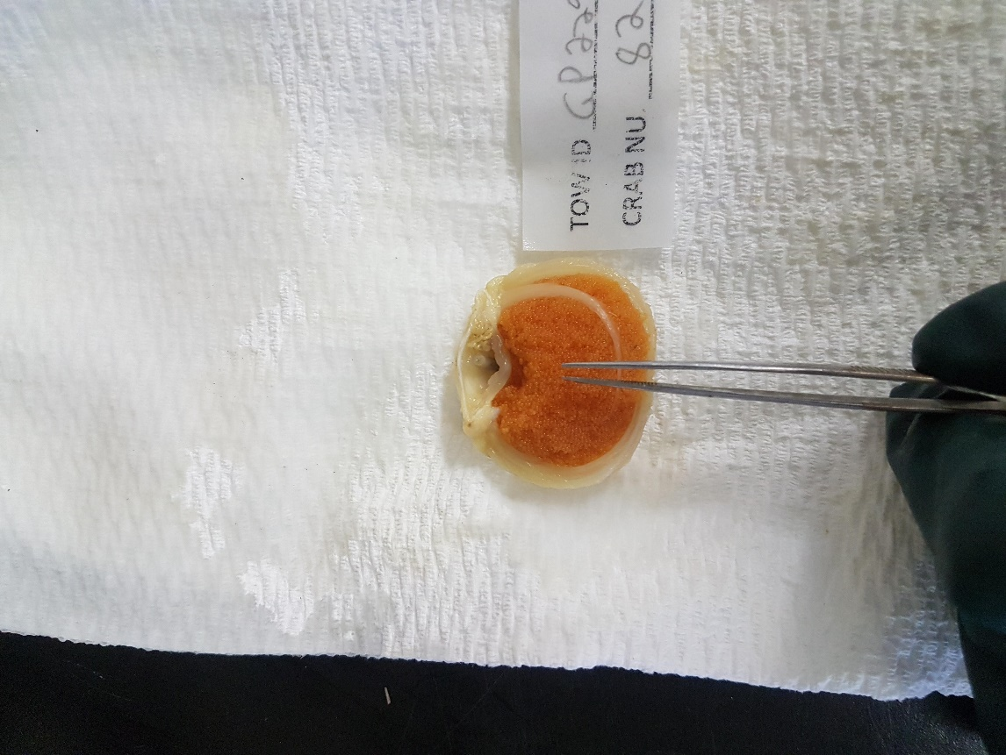 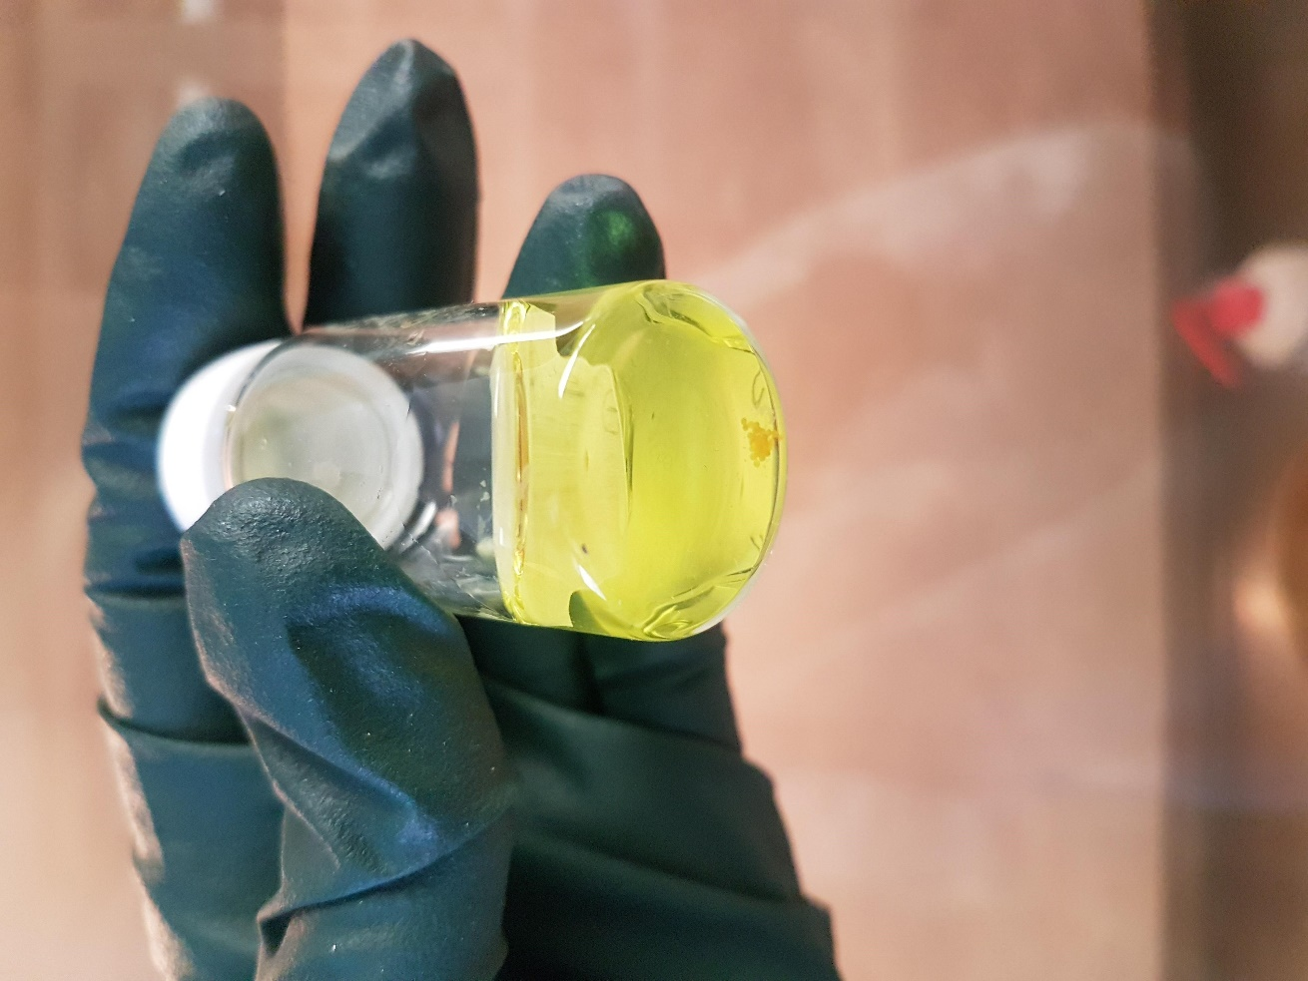

Figure 3. Extraction of sub-sample (~10 eggs) from center of Figure 4. Sub-sample of eggs (circled) in 4% Bouin’s solution

egg mass for embryonic stage determination. for embryonic stage determination.

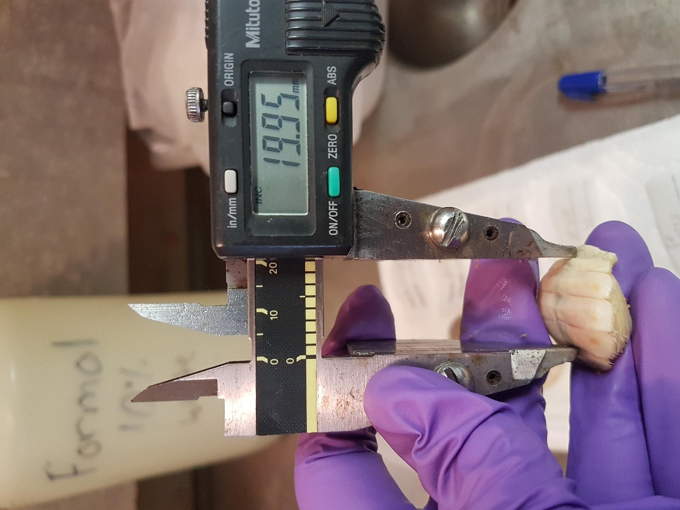 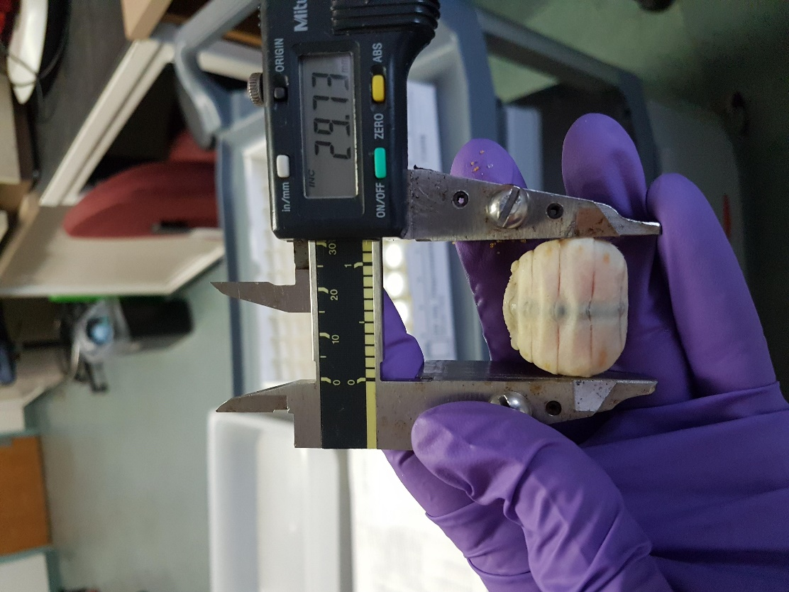

Figure 5: Abdomen height measurement with Vernier caliper. Figure 6: Abdomen width measurement.

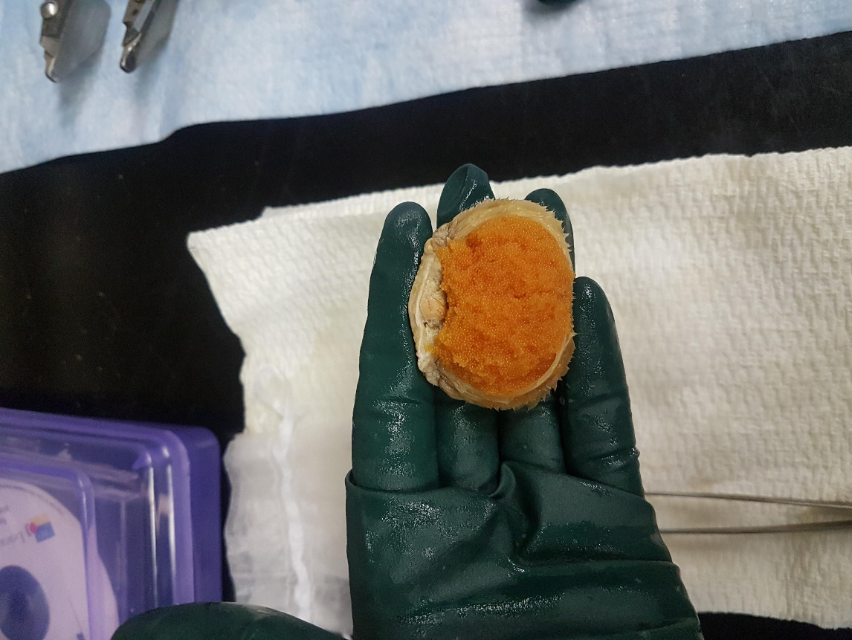 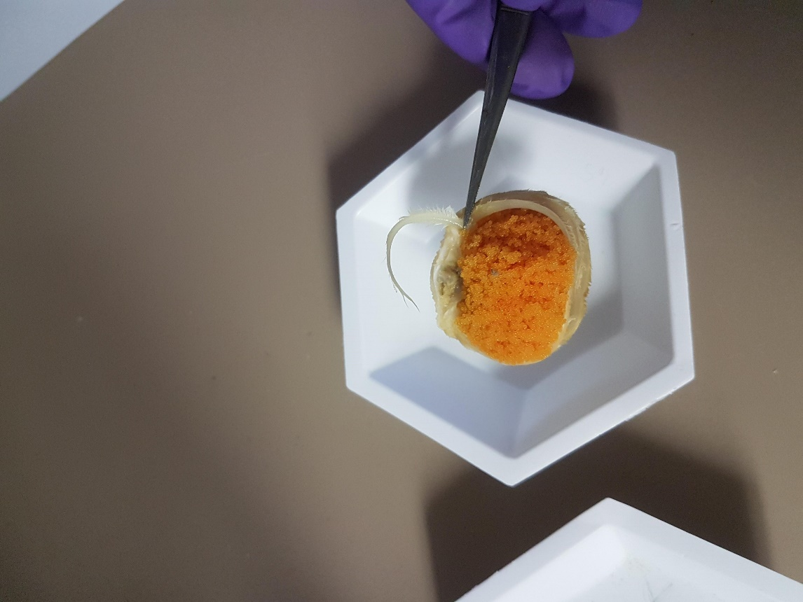

Figure 7. Egg mass and location of gonad tissue to be removed Figure 8. Proximal setae (arrow).

(circled), if present.

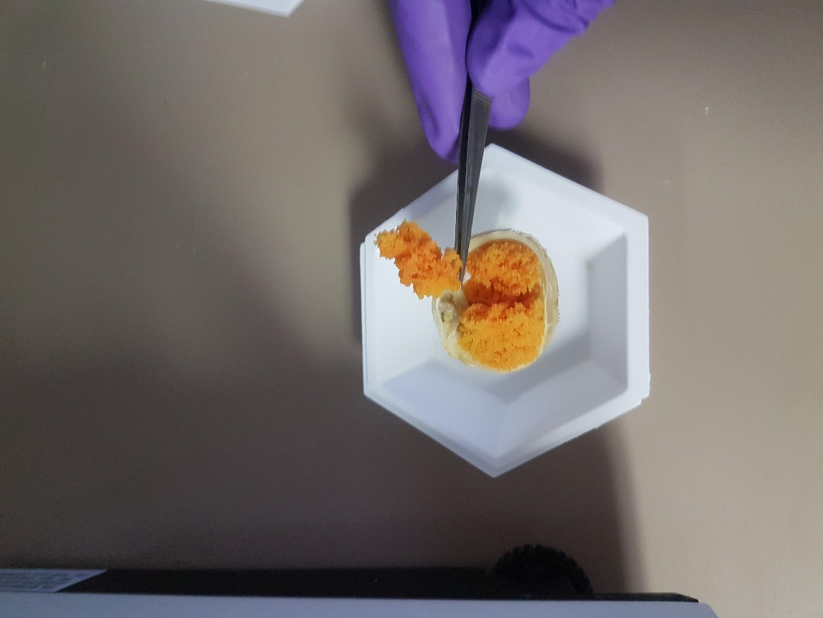 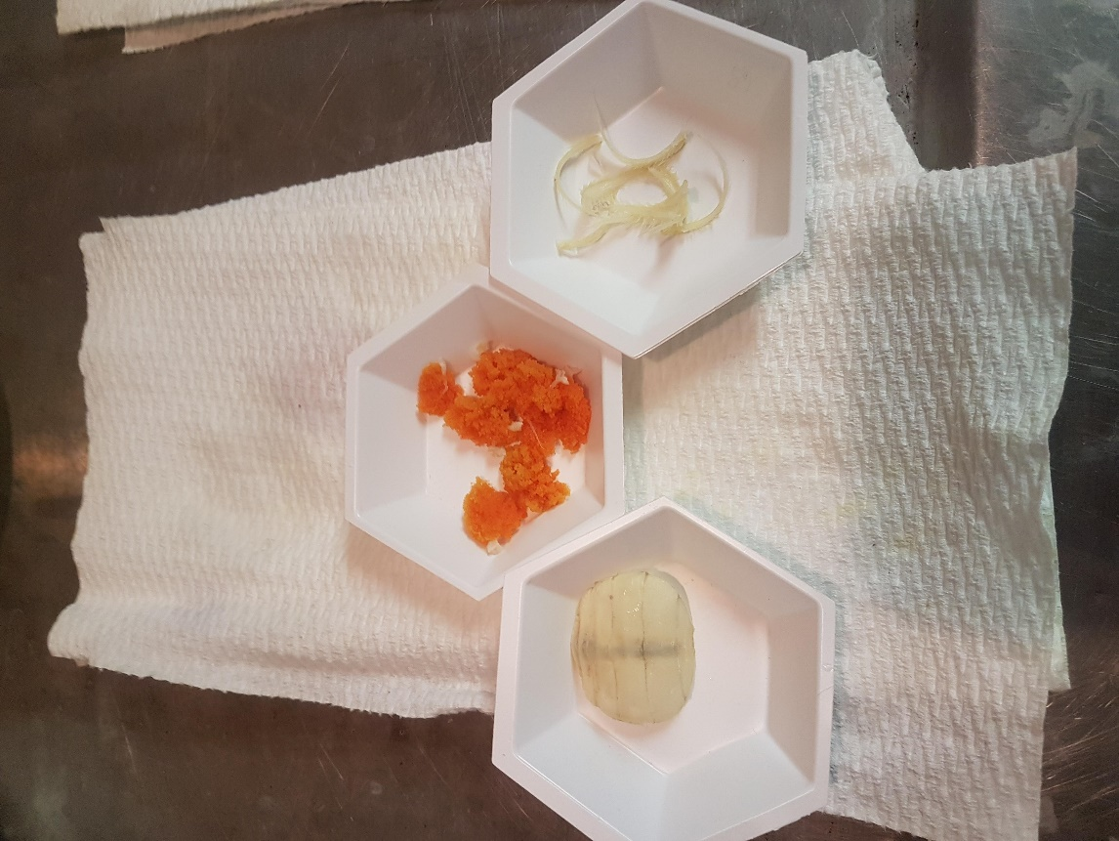

Figure 9. Proximal egg cluster. Figure 10. Abdominal flap, egg clusters and setae separated.

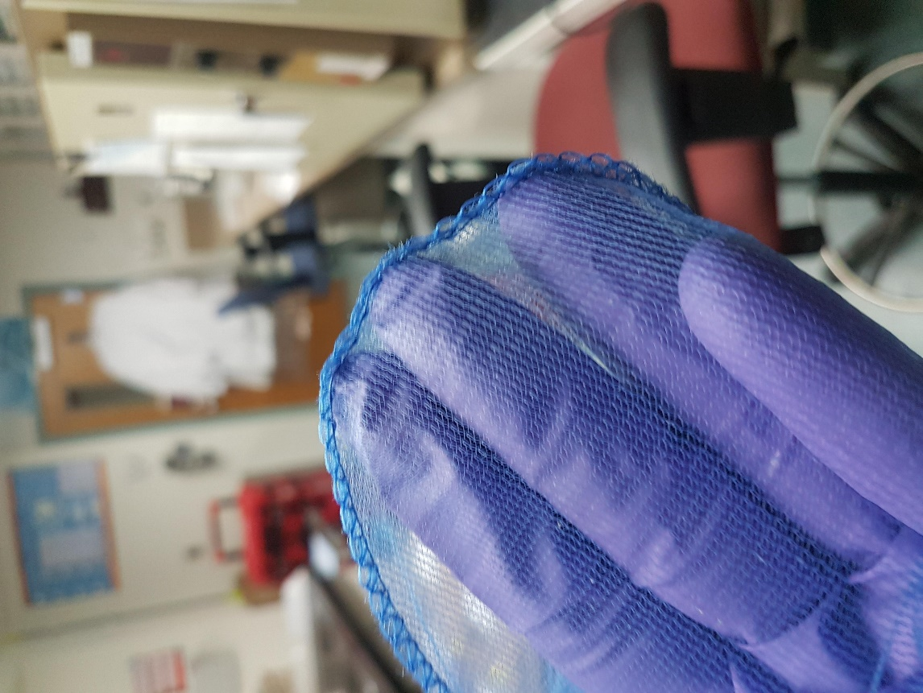 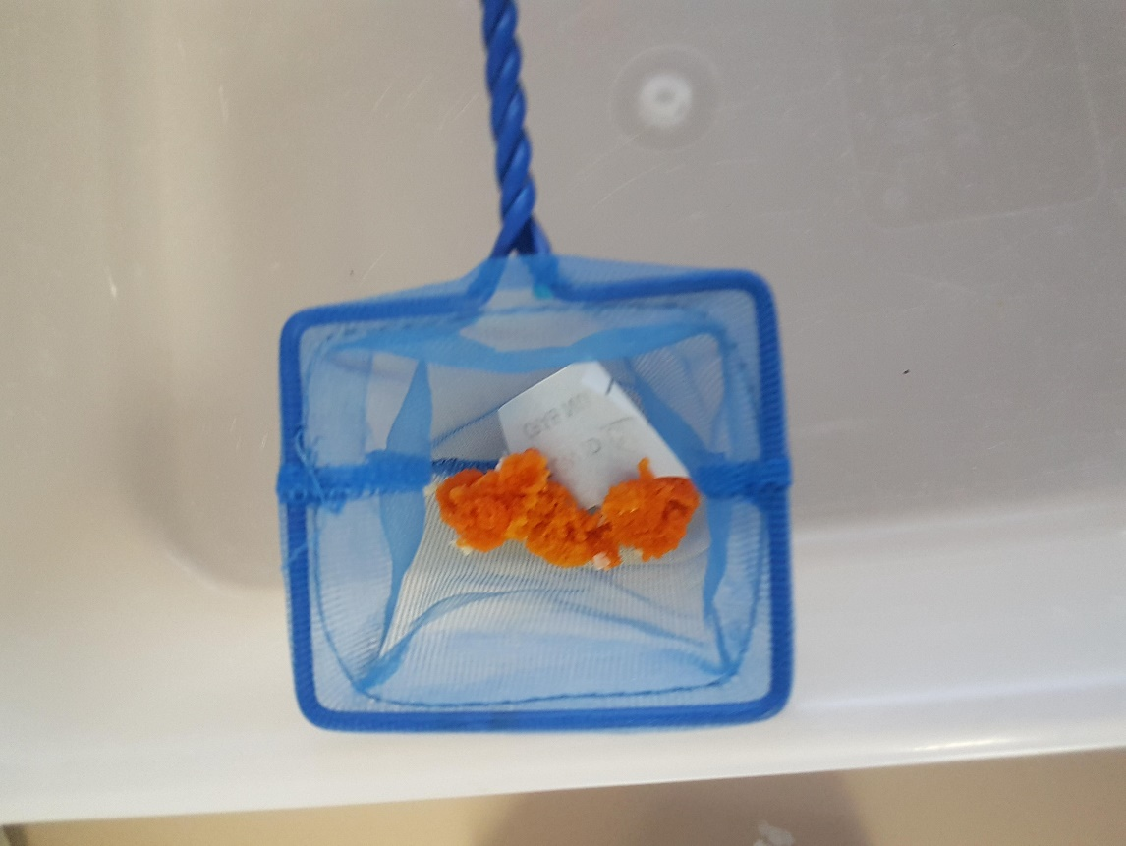

Figure 11. Stitching on outside of net. Figure 12. Pleopods in net with duplicate tag ready to be rinsed.

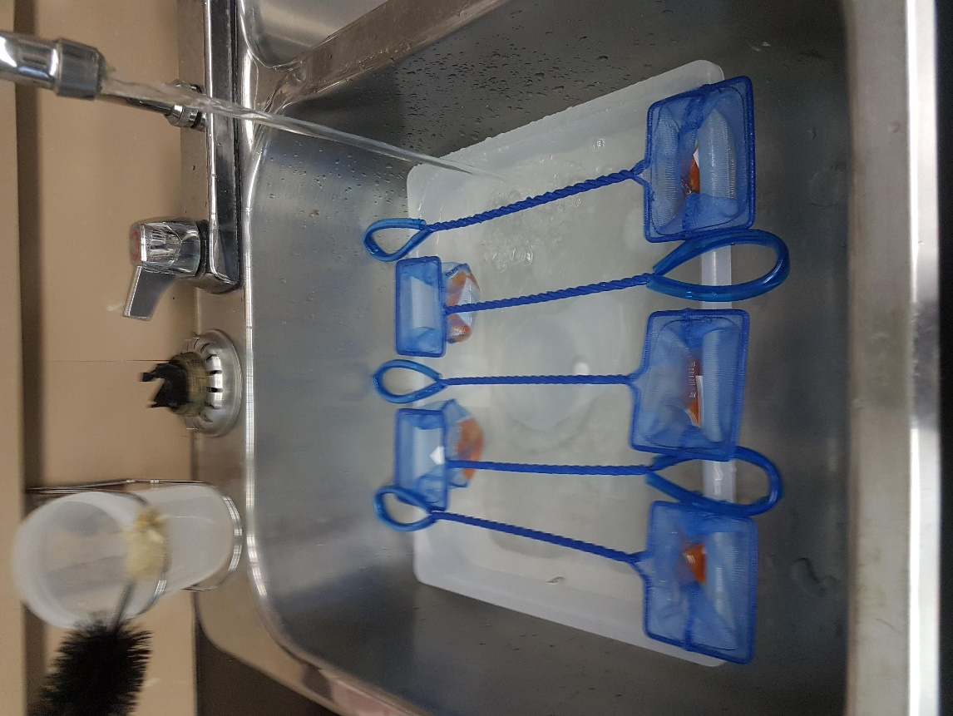 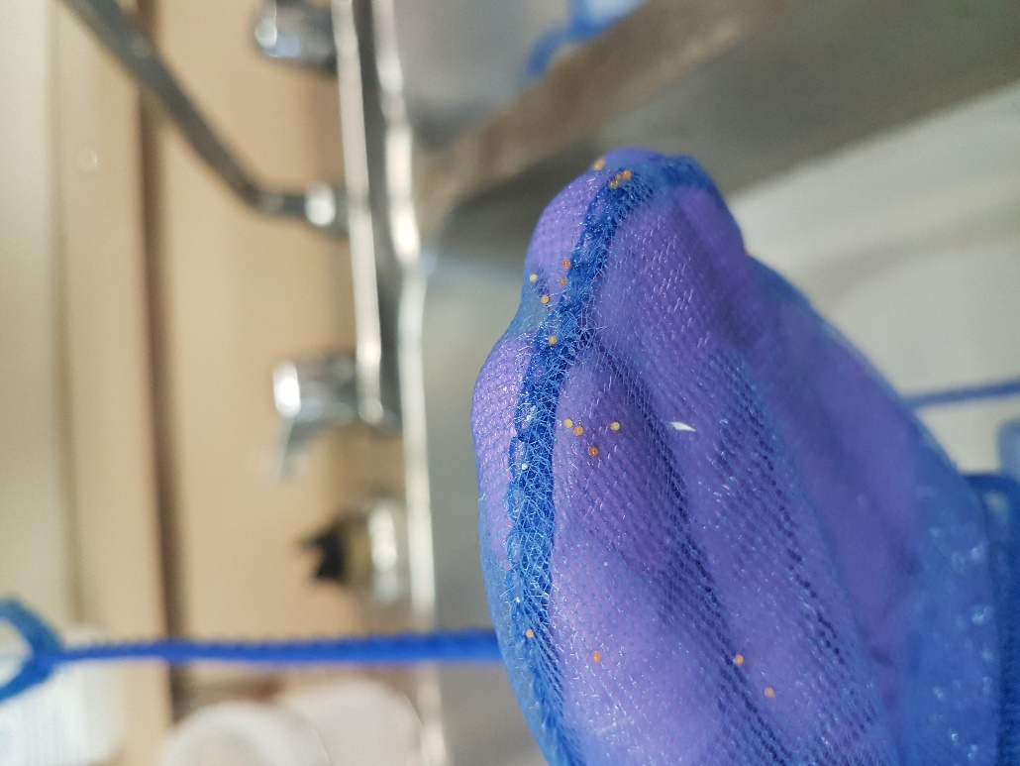

Figure 13. Rinsing eggs with cold water for at least 30 mins. Figure 14. Eggs remaining on net after rinsing.

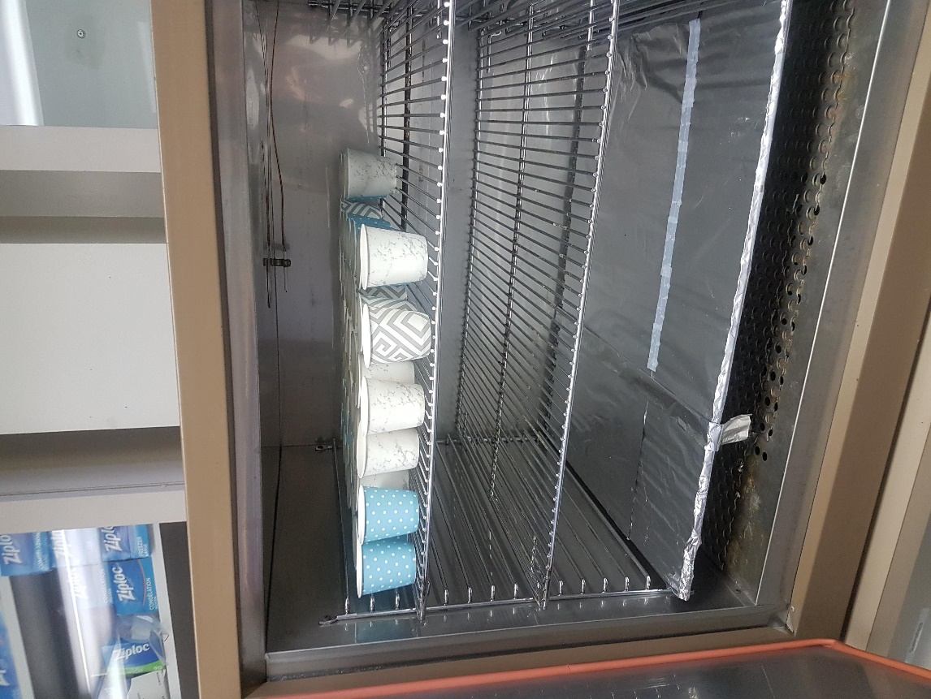 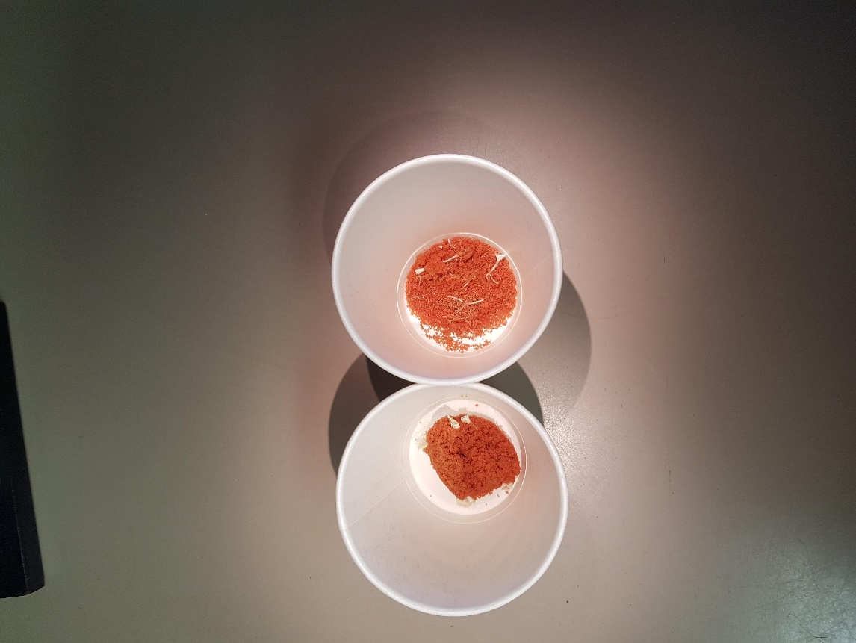

Figure 15. Eggs in paper cups in drying oven. Figure 16. Dried eggs (not cleaned).

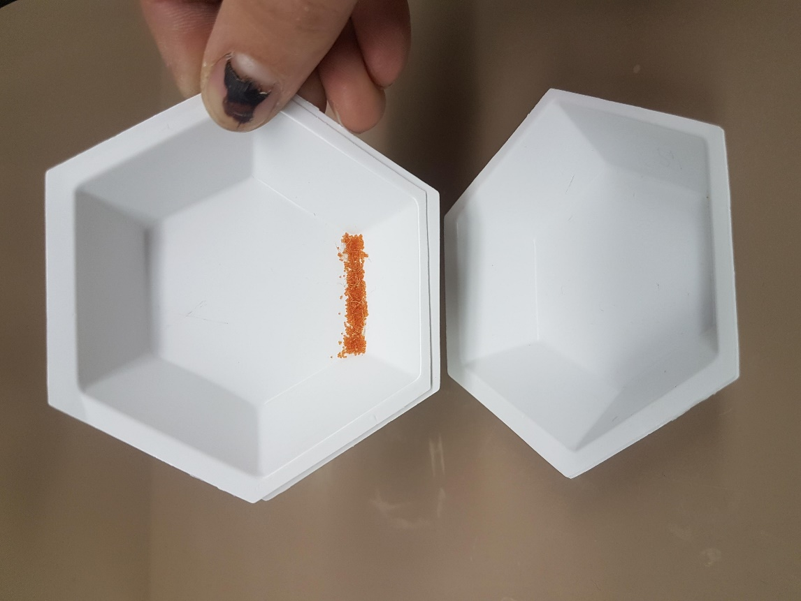 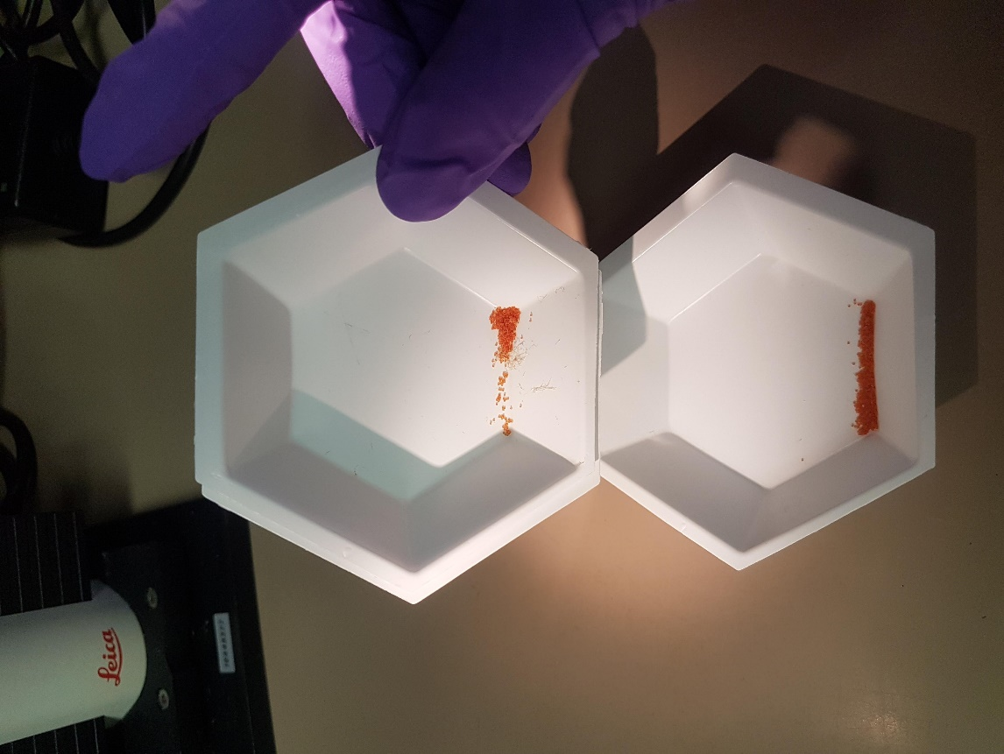

Figure 18: Sprayed dishes used for cleaning. Gather eggs on Figure 19. Gently tap side of dish to transfer small amount of

side of dish. eggs into empty dish while removing residue and debris

(circled). Repeat until no dust/debris remain.

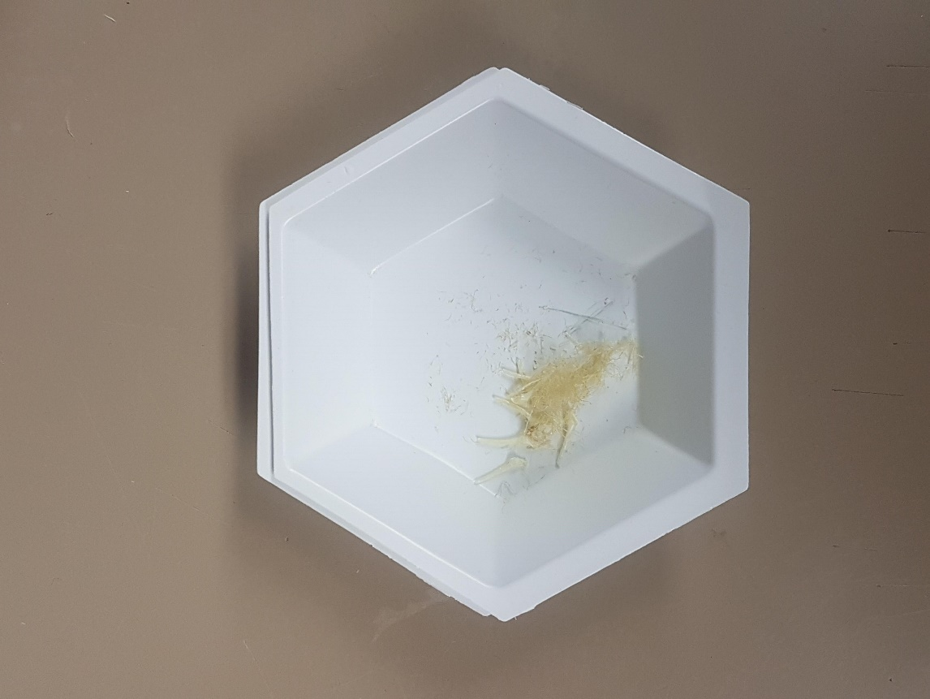 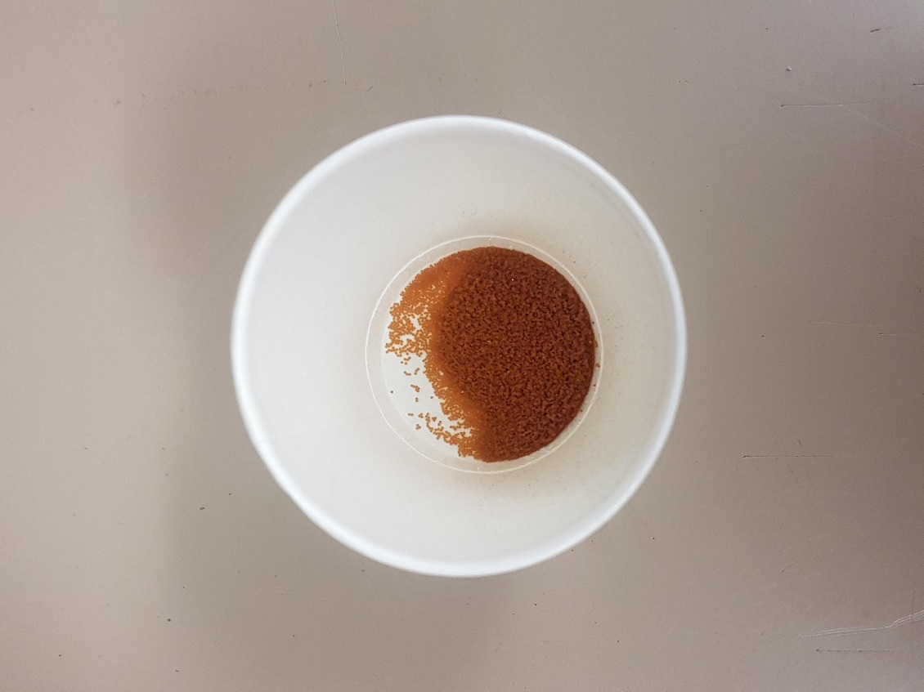

Figure 19. Residue collected from cleaning. Figure 20. Cleaned eggs.

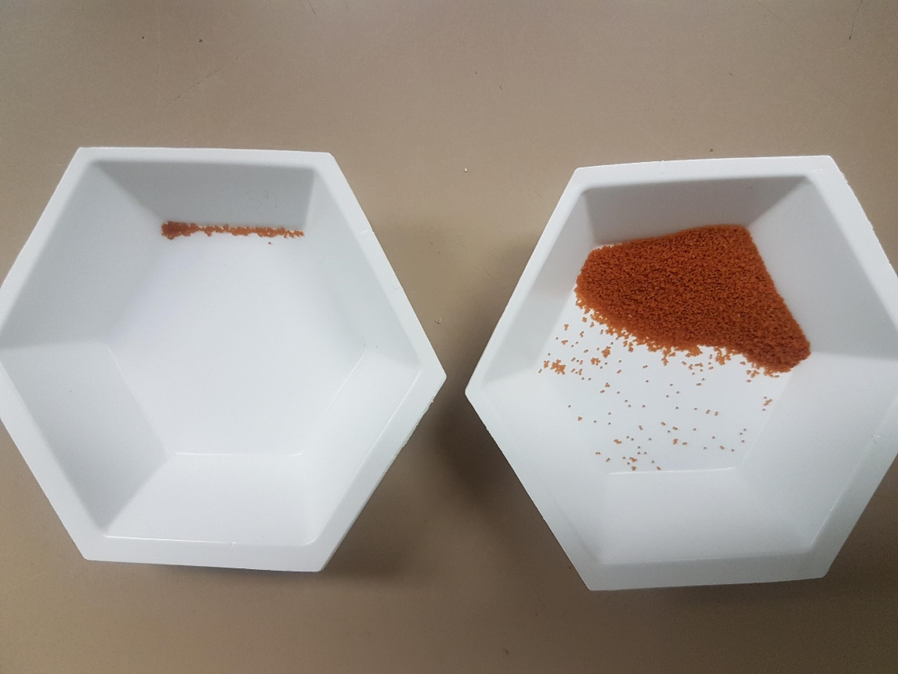 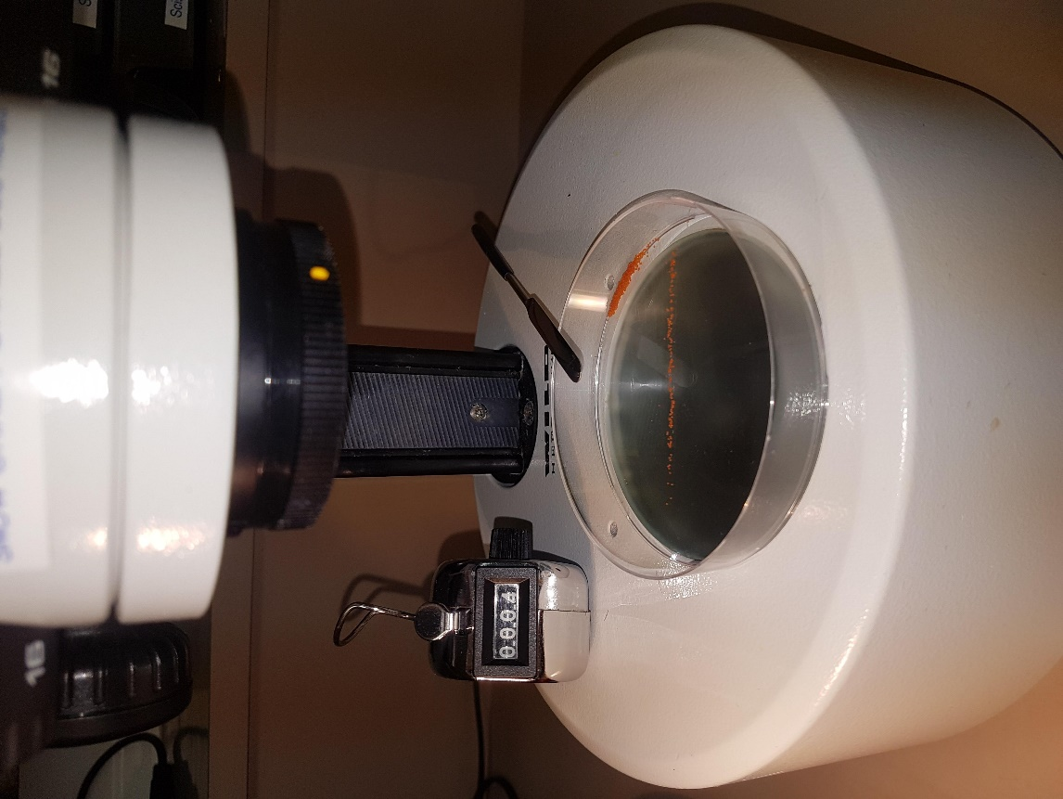

Figure 21. Sub sample (top) for counting and remainder of eggs Figure 22. Sub sample (~500 eggs) ready to count under miscroscope.

(bottom).